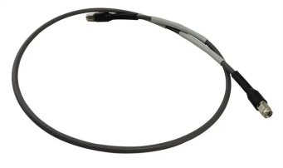LHS107-SMSM-XM ultra low loss phase stable flexible cable assemblies

|  |  |
| --- | --- |
| Leader-mw | Specification |

|  |  |
| --- | --- |
| Frequency Range: | DC~ 18000MHz |
| Impedance: . | 50 OHMS |
| Time delay:（nS/m） | 4.01 |
| VSWR: | ≤1.3 : 1 |
| Dielectric voltage: | 1600 |
| shielding efficiency (dB) | ≥90 |
| Port Connectors: | SMA-male |
| transmission rate (%) | 83 |
| Temperature phase stability (PPM) | ≤550 |
| Flexural phase stability (°) | ≤3 |
| Flexural amplitude stability (dB) | ≤0.1 |

Outline Drawing:

All Dimensions in mm

Outline Tolerances ± 0.5(0.02)

Mounting Holes Tolerances ±0.2(0.008)

All Connectors: SMA-M

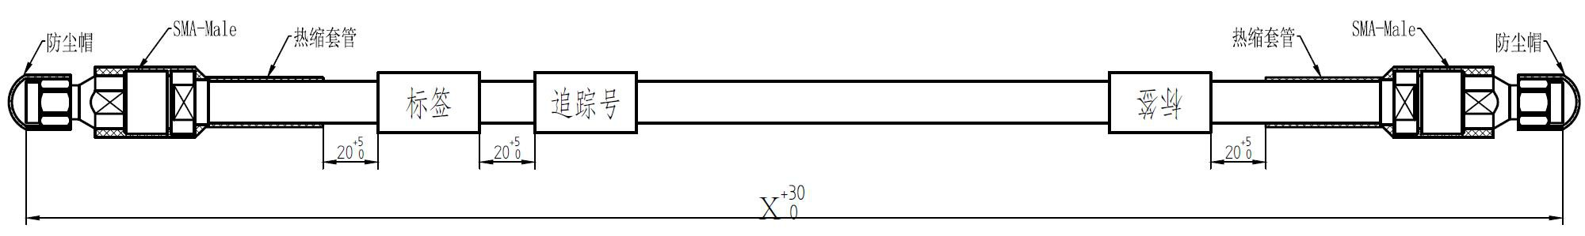

|  |  |
| --- | --- |
| Leader-mw | Mechanical and environmental performance |
| Cable outer diameter (mm): | 7.5 |
| Minimum bending radius (mm) | 75 |
| Operating temperature (℃) | -50~+165 |

|  |  |
| --- | --- |
| Leader-mw | Attenuation(dB) |
| LHS107-SMSM-0.5M | 0.9 |
| LHS107-SMSM-1M | 1.2 |
| LHS107-SMSM-1.5M | 1.55 |
| LHS107-SMSM-2.0M | 1.85 |
| LHS107-SMSM-3M | 2.55 |
| LHS107-SMSMM-5M | 3.9 |